The Efficacy of GDP as a Proxy for Societal Well-Being

Mason Ogden, California Polytechnic State University – San Luis Obispo, California

# Abstract

Gross Domestic Product, or GDP, is both one of the most widely used economic metrics and one of the most controversial. GDP is often seen as a general measure of well-being, wealth, development, and even quality of life. Detractors of the metric say that it simply measures how large an economy is, not living conditions or general health of those in that economy. Additionally, naysayers often accuse the pursuit of a higher GDP as being incompatible with environmental sustainability. Meanwhile, supporters of GDP acknowledge that the calculation fails to directly account for income equality, education, gender equality, and much more, but is a proxy for those things. That is, many aspects of society that cannot be directly measured with a dollar value do not factor into the number but are said to be ‘directly correlated’ with GPD.

# Introduction

In this paper, I will explore investigate the relationship between GDP and various ‘positive’ non-economic measures of a country’s well-being, such as life expectancy and gender equality, as well as explore the relationship between GDP and ‘negative’ measures, such as CO2 emissions, income inequality, . These relationships will most likely vary by country and region, so that will be taken into account as well. Furthermore, I will discuss the Human Development index (HDI) and compare it to GDP.

# GDP as a PRoxy for Positive non-economic measures

Is it true that there are strong relationships between GDP and non-economic measures, even if those relationships are not necessarily causal? To answer this question, I combined data from gapminder.org with Gender Inequality Index (GII) data, and then examined the relationships between GDP and life expectancy and gender equality across time. As a case study, only the United States was analyzed, as there was not available GII data on all countries and regions present in the gapminder data. An additional difficulty was that GII data started being recorded in 1995, and is was not recorded every year.

For each measure, I will examine graphs and correlations, as well as conduct statistical tests as appropriate to quantify the strength of the relationships.

## Life Expectancy

Do life expectancy and GDP vary together? The first year of data in which life expectancy and GDP data were recorded in the US was 1960. First, I looked at a scatterplot of GDP vs. life expectancy:

Figure 1. Relationship between GDP and Life Expectancy

The above graph shows a clear positive, mostly linear relationship between GDP and life expectancy. But to quantify this relationship I looked at the correlation between the two. I found that there is a very strong, positive, linear relationship between the two (*r* = 0.97246).

Additionally, I wanted to run a simple linear regression with life expectancy as the response and GDP as the predictor. But first I had to ensure that this was a valid assumption by checking the conditions. It is clear from the plot that there is a linear relationship between the two variables, and I’d venture to say the observations are independent. According to a Shapiro-Wilks test for normality, there’s not enough evidence to say that the residuals do not come from a Normal Distribution, so normality is satisfied. Finally, there is no fan shape in the residuals vs. fitted values plot, so there’s reasonably constant variance across values of GDP.

There is very strong evidence (*p* < 0.0001) that life expectancy is associated with GDP. So, I answered my question. GDP and life expectancy do vary together. One thing to take into account when interpreting this relationship is that while life expectancy is not *directly* taken into account in the calculation of GDP, one could argue that it is *indirectly* taken into account. The longer people live, the longer they are able to work, producing goods and services that contribute to GDP. If every person in the United States dropped dead on their 30th birthday, we would not have as productive an economy.

## Gender Equality

I’ve established that there’s a relationship between GDP and life expectancy. What about something a little less concrete: gender equality? The Gender Inequality Index was first formulated in 1995 as part of the Human Development Report by the United Nations. Because gender inequality is detrimental to a nation’s economy as a whole, this metric measures the ‘the loss of achievement within a country due to gender inequality’ (SOURCE). It takes into account reproductive health, empowerment, and economic status, and takes a value between 0 and 1. Lower values represent more equality, while higher values represent less equality. For reference, in 2017 the country with the lowest value was Switzerland with a score of 0.039, while the highest value was Yemen, with 0.834. The Untied States sits at 0.189 (41st place).

Another problem is that, while data collection began in 1995, it was not consistent. After 1995, data was sparse for a time, only recording 2005 and 2010, but then recording every year up until 2018 after that. Below is a figure showing the relationship between GDP and GII:

Figure 2. Relationship between GDP and Gender Inequality

There appears to be small-to-moderate negative linear relationship in the points above. The relationship is not strong enough to be confident in without looking at numbers first. So, I first calculated the correlation between the two variables, and found that there is a very strong, negative linear relationship between GDP and gender inequality (*r* = -0.95136), meaning increasing GDP is associated with decreasing gender inequality.

Running a simple linear regression on these measures, the small sample size (11 years) turned out to be problematic, as having such a small number of points can lead to unstable parameter estimates. Additionally, 1995 proved to be a very highly influential point with high leverage. In most situations, this point would be removed in order to get a better-fitting line, but there was barely any data to begin with in this situation. So, I cannot trust the results of the regression.

Based on the correlation coefficient alone, I am confident that these two measure are highly correlated. Just like with life expectancy, while GDP does not directly measure gender inequality, according to the creators of the Gender Inequality Index, inequality leads to loss of achievement and potential, therefore affects the production of goods and services.

# GDP’s Relationship with Negative Non-economic measures

If GDP measure a country’s total output of goods and services, then how can it address things like environmental sustainability and income inequality? The ‘externalities’ (to use an economics term) of production do not factor into the equation. Things like air pollution negatively impacting health, or billionaires technically producing more and more, gaining wealth while some people can’t afford their medications. To see how GDP squares with these effects,

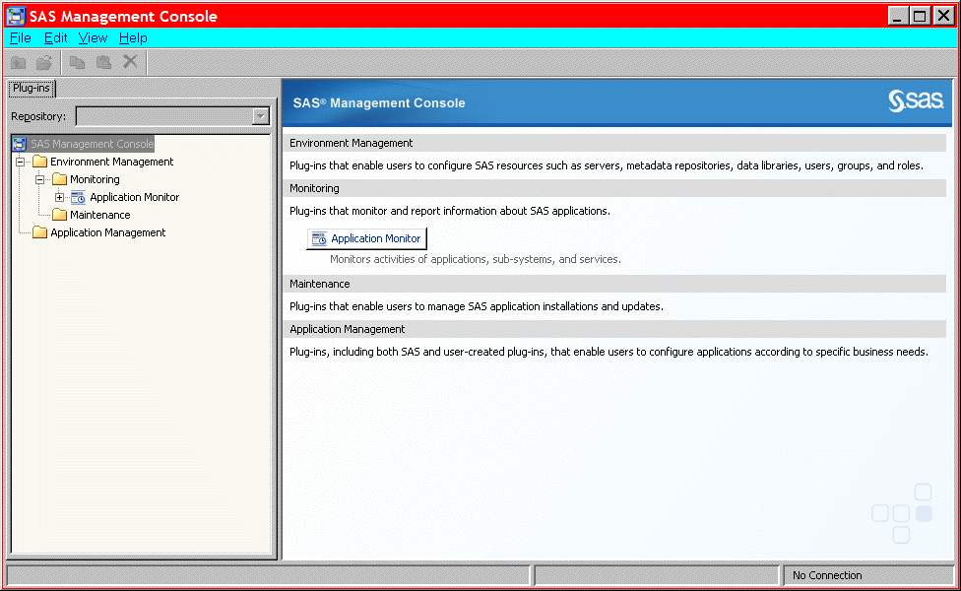

Display . Former Main Interface for SAS Management Console

Use captions for displays.

## Literacy

This is subtopic for the above. This is the paper body. This is the paper body. This is the paper body. This is the paper body. This is the paper body. This is the paper body. This is the paper body.

If you need to include SAS output, this is an example of how to present it:

Output 1 shows an example of how to present output.

CREATE TABLE ALLACCTX(SourceSystem varchar(4),

cctnum numeric(18,5) CONSTRAINT "ALLACCT_PK" PRIMARY KEY,

ccttype numeric(18,5),balance numeric(18,5),clientid numeric(18,5),

losedate date,opendate date,primary_cd numeric(18,5),status varchar(1))

Output . Output from a CREATE TABLE Statement

Use captions for output. Note that output is the same font as source code, but it is in a box. (Not a Text box.)

Continuation of paper body—after output.

## Subhead A Level <heading 2>

This is the paper body. This is the paper body. This is the paper body. This is the paper body. This is the paper body. This is the paper body. This is the paper body. This is the paper body. This is the paper body. This is the paper body.

### Subhead B Level <Heading 3>

This heading level is for a subtopic of a secondary topic. This is the paper body. This is the paper body. This is the paper body. This is the paper body. This is the paper body. This is the paper body. This is the paper body. This is the paper body. This is the paper body. This is the paper body.

#### Subhead C Level <Heading 4>

This is the paper body. This is the paper body. This is the paper body. This is the paper body. This is the paper body. This is the paper body. This is the paper body. This is the paper body. This is the paper body. This is the paper body.

# Conclusion <heading 1>

The conclusion summarizes your paper and ties together any loose ends. You can use the conclusion to make any final points such as recommendations, predictions, or judgments.

This is the text for the paper’s conclusion. This is the paper body. This is the paper body. This is the paper body. This is the paper body. This is the paper body. This is the paper body.

# References <heading 1>

This section is not required. Use a bulleted list if you have more than one reference. The references below are examples and do not cover the spectrum of examples that might be included. The important thing is to be consistent in the formatting and organization of your references. If you prefer, you can follow a bibliographic approach such as the American Psychological Association (<http://www.apastyle.org/manual/index.aspx> ) or the American Statistical Association (<http://pubs.amstat.org/page/styleguide> ).

This is the text for the references.

Book <Author name: last name, first name>. <Copyright date>. <*Book title*>. <page numbers>. <City, State of Publisher>: <Publisher name>

Journal article <Author name: last name, first name>. <Copyright date>. “<Article title>.” <*Journal title*>. <page numbers>. <City, State of Publisher>: <Publisher name>

Article in conference proceeding <Author name: last name, first name>. <Copyright date>. “<Article title>.” <*Title of proceedings such as Proceedings of the SAS Global 2010 Conference*>. <City, State of Publisher>: <Publisher name> Optional: You can add a URL to access available online copies. For example: Available at <http://support.sas.com/resources/papers/proceedings09/TOC.html>.

Web site <Author name: last name, first name>. “<Title>.” <*Source*>. <Date>. Available at <URL>.

# Acknowledgments <heading 1>

This section is not required.

This is the text for the acknowledgments. This is the paper body. This is the paper body. This is the paper body. This is the paper body. This is the paper body.

# Recommended Reading <heading 1>

This section is not required. Use a bulleted list if you have more than one reference. This is the format for recommended reading.

* Base SAS® Procedures Guide
* SAS® For Dummies®

# Contact Information <heading 1>

In case a reader wants to get in touch with you, please provide your contact information.

Your comments and questions are valued and encouraged. Contact the author at:

Name:

Enterprise:

Address:

City, State ZIP:

Work Phone:

Fax:

E-mail:

Web:

The next two paragraphs are **required** and need to remain in the paper.

SAS and all other SAS Institute Inc. product or service names are registered trademarks or trademarks of SAS Institute Inc. in the USA and other countries. ® indicates USA registration.

Other brand and product names are trademarks of their respective companies.

Page of Formatted Samples

This page has samples that you can copy into the body of your paper and adapt as necessary for your content.

**Note**: Delete this page before submitting your paper.

**Source Code Sample**

data one;

set two;

if mix(var1, var2) > 0 then do;

**List: Numbered or Ordered**

1. numbered list item
2. numbered list item
3. numbered list item

**List: Bulleted or Unordered**

* This is a sample bulleted list item.
* This is a sample bulleted list item.

**Output Sample**

CREATE TABLE ALLACCTX(SourceSystem varchar(4),

cctnum numeric(18,5) CONSTRAINT "ALLACCT_PK" PRIMARY KEY,

ccttype numeric(18,5),balance numeric(18,5),clientid numeric(18,5),

losedate date,opendate date,primary_cd numeric(18,5),status varchar(1))

Output . Output from a CREATE TABLE Statement

**Table Sample**

| **Heading for Column 1** | **Heading for Column 2** | **Heading for Column 3** | **Heading for Column 4** |
| --- | --- | --- | --- |
|  |  |  |  |
|  |  |  |  |
|  |  |  |  |

Table . Sample Table

Basic Instructions to Insert Captions, Cross-References, and Graphics

These instructions are written for MS Word 2007 and 2010. The steps are similar for MS Word 2003.

To insert a caption:

1. Click **References** on the main Word menu.
2. Click **Insert Caption**.
3. Select the **Label** type you want.
4. Click **OK**.

To insert a cross-reference:

1. Click **References** on the main Word menu.
2. Click **Cross-reference**.
3. In the **Reference type** list box, select Figure, Table, Display, or Output.
4. In the **For which caption** list, select the caption you want.
5. From the **Insert reference to** list, select **Only label and number**.

To insert a graphic from a file:

1. Click **Insert** on the main Word menu.
2. Click **Picture**.
3. In the Insert Picture dialog box, navigate to the file you want to insert.
4. When the name of the file you want to insert is displayed in the **File name** box, click **Insert**.